

**Centennial Legion of Historic Military Commands**

81th Annual Meeting

27th – 29th, October 2016

Plymouth, Massachusetts

Hosted by

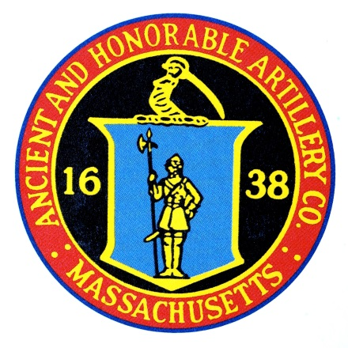

The Ancient and Honorable Artillery Company of Massachusetts

Headquarters Hotel:

**Hotel 1620 at Plymouth Harbor (formerly Radisson-Plymouth)**

**Group Name: Centennial Legion of Historic Military Commands**

Room Rates: $149 per night + tax

Reservations: 508-747-4900

Events Include: (subject to modification)

* Mayflower Society House Cocktail Reception
* Plymouth Yacht Club Friday Night Dinner-Cannon and Musket Fire
* First Fort Burial Hill- Pilgrim Hall Museum- Mayflower II- Plimoth Plantation
* Grand Parade with Salutes
* Grand Banquet at Radisson Hotel

Event Registration at Later Date

Book Hotel Reservation(s) now due to limited quantity